THE YELLOW PRACTICE
Tel: 01738 621 726
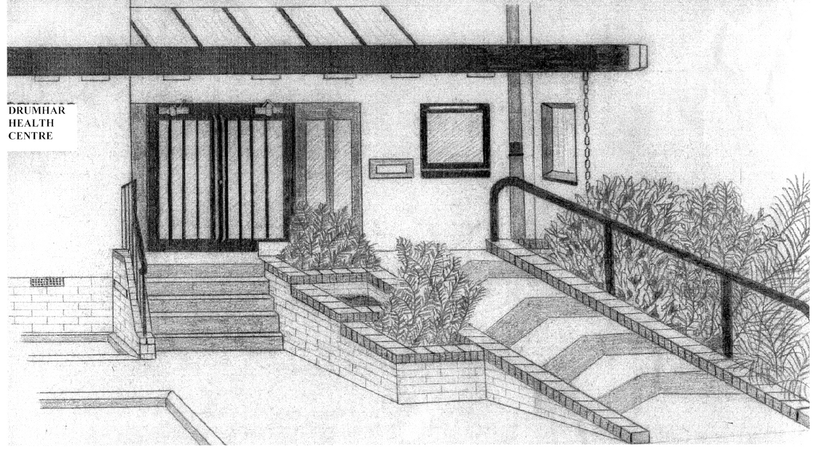
Drumhar Health Centre
North Methven Street
Perth
PH1 5PD

June 2021

This practice is now offering online services

You can now order repeat prescriptions online.

This surgery has a responsibility to look after your GP records. You must also take care online and make sure that your personal information is not seen by anyone who should not see it.
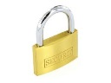
Keeping your username and password safe

When you register to use GP online services, you will create your own username and password, which you will use to log in. You should not share your login details with others.
To protect your information from other people:
- You should keep your password secret and it is best not to write it down. If you must write it down, keep a reminder of the password, not the password itself. This should be kept in a secure place.
- If you think someone has seen your password, you should change it as soon as possible. You may want to call the surgery if you are not able to change it right away, for example, when you do not have access to the internet.
- You should not share your user name or password. No one should force you to show them your login details; you have the right to say no. If someone forces you, tell the surgery as soon as possible.

Using a shared computer

You need to take extra care when using a shared computer to look at your GP records online. This could be at the library, at work, at university or at home. To protect your personal information from others when using a shared computer, you should:

- Look around to see if other people can see what is on the computer screen. Remember, your GP records contain your personal information.

- Keep your username and password secret. Just like your bank account PIN, you would not want others to know how to get into your GP records.

- Make sure you log out when you finish looking at your records, so that no one else can see your personal information or change your password without your knowledge.

